**Public Speaking - ML**

**Today you are going to do some research on public speaking!**

**Part 1 – Research**

*INSERT TABLE HERE*

1. Click above where it says “INSERT TABLE HERE”. Click Insert, then click on table.
2. Use your mouse to highlight a 3x6 area

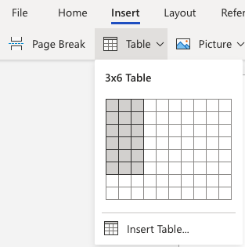

1. Once you have a 3x6 click on the box. A table should pop up in your document.
2. Label the first box in column 1 **Question**
3. Label the first box in column 2 **Answer**
4. Label the first box in column 3 **Website Link**
5. In column 1, row 2, type the question **What is public speaking?**
6. In column 1 row 3, type the question **What are the qualities of a good public speaker?**
7. In column 1, row 4, type the question **How can someone calm their nerves before public speaking?**
8. In column 1, row 5, type the question **What are effective speaking skills?**
9. In column 1, row 6, type the question **What are some public speaking tips?**

**Part 2 - Research**

Please fill in the chart you made above using google to help you find the answers. Type each question into google and find an answer. Type your answers in the box next to the question. Do not copy and paste your answers directly. Then, copy and paste the link into the third box. Attach the link to the website you used to find the answer.

**Part 3 - Pictures**

1. Click Insert, then click on table.
2. Use your mouse to highlight a 2x6 area.
3. Once you have a 2x6 area, click on the box. A table should pop up in your document.
4. Label the first box in column 1 **Pictures**
5. Label the first box in column 2 **Website**

*INSERT TABLE HERE*

**Part 4 - Pictures**

Research and find 5 pictures for public speaking. In google images type “Public Speaking.” Click on the picture and copy and paste it into the table you made above. Attach the link to the website you used in the chart above.

**Part 5 - Videos**

1. Click Insert, then click on table.
2. Use your mouse to highlight a 2x6 area.
3. Once you have a 2x6 area, click on the box. A table should pop up in your document.
4. Label the first box in column 1 **Video Links**
5. Label the first box in column 2 **Comments**

*INSERT TABLE HERE*

**Part 6 - Videos**

1. Please find and watch 3 YouTube videos about public speaking tips for students. These should be videos YOU find fun and interesting. Copy and paste the links in your table above. When you have finished watching a video write 1-2 sentences about what you liked best about the video in the box next to where you put the link.